
CONFIDENTIAL CS/NOV 2026/ICT450

UNIVERSITI TEKNOLOGI MARA FINAL EXAMINATION

COURSE
COURSE CODE
EXAMINATION TIME
DATABASE DESIGN AND DEVELOPMENT

ICT450
NOVEMBER 2026
3 HOURS

INSTRUCTIONS TO CANDIDATES

- This question paper consists of five (5) questions.

- Answer ALL questions in the Answer Booklet. Start each answer on a new page.

- Do not bring any material into the examination room unless permission is given by the invigilator .
- Please check to make sure that this examination pack consists of: i) the Question Paper
  - an Answer Booklet - provided by the Faculty

- Answer ALL questions in English.

DO NOT TURN THIS PAGE UNTIL YOU ARE TOLD TO DO SO

This examination paper consists of 6 printed pages.

QUESTION 1 (20 marks)
a) Data is essential to organizations for business operations. Identify FOUR (4) examples of data that exist in a student registration database system.
(4 marks)
b) The transition from manual data management to the computerized file processing system marked a significant milestone in organizational efficiency. Nonetheless, this approach presented several inherent challenges that limited its long-term viability. State FOUR (4) limitations associated with the traditional computerized file system approach.
(4 marks)
c) A data dictionary is a crucial component of any robust database system. Describe THREE (3) features that are important in a data dictionary.
(6 marks)
d) The Database Life Cycle (DBLC) is a cycle that traces the history of a database within an information system. Indicate SIX (6) phases of the DBLC.
(6 marks)
QUESTION 2 (20 marks)
a) The network model was created to represent complex data relationships more effectively than the hierarchical model. However, as information needs grew and more sophisticated databases and applications were required, the network model became too cumbersome. Describe TWO (2) disadvantages of network model.
(4 marks)
b) Table 2 shows the data from a publishing company. Briefly explain TWO (2) reasons why this table violates the characteristics of a relational table.
(4 marks)
Table 2: Books table
ISBN | BookTitle | Authors | Publisher ID | Publisher Name
978-981-4824-24-7 | Database Systems | Coronel, Morris | 101 | Cengage Learning
978-967-388-341-7 | Innovation via Arduino | Hafizah Hussain | 103 | John Wiley & Sons
978-967-86-1017-9 | Healing the Invisible Wound | Ahmad Rostam, Rozaniza, Alizi Alias | 102 | Karangkraf Media Group
978-981-4824-24-7 | Digital Multimedia | Nigel, Jenny | 102 | Karangkraf Media Group
c) In a database design process, there are two views of data within the system, which are the business view and the designer's view. Briefly explain THREE (3) views for the designer.
(6 marks)
d) Describe THREE (3) benefits of big data to companies.
(6 marks)
QUESTION 3 (20 marks)
The following questions will be based on order form in Table 1.0.
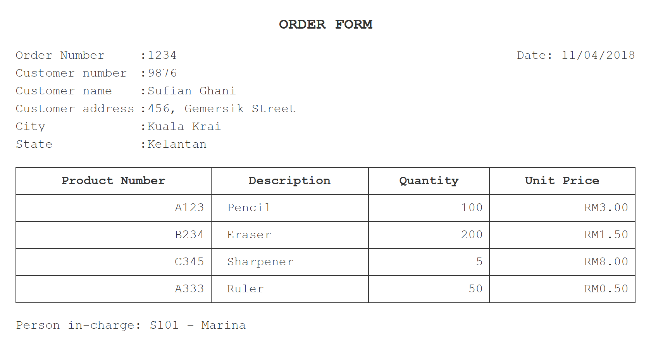
Table 1.0 : Order For Sufian Shop
a) Convert the order form in Table 1.0 into a relational schema format.
(2 marks)
b) State the primary key(s) in (a).
(2 marks)
c) Normalize the table until third normal form (3NF). Show all your work.
(16 marks)
QUESTION 4 (20 marks)
Based on the relational schema used in Aprilbank Banking System, write SQL commands for the following questions.
BANK (bankCode, bankName, bankAddress)
ACCOUNT (accNo, balance, accType, branchCode)
LOAN (loanNo, amount, loanType, branchCode)
CUSTOMER (custIC, custName, custAddress, branchCode)
BRANCH (branchCode, branchAddress, bankCode)
a) Create ACCOUNT table.
(3 marks)
b) Customer phone number is important for this system. Add customer phone number attribute and named it as 'custPhone'.
(2 marks)
c) Find total number of customers who opened their account at Aprilbank.
(2 marks)
d) Find the list of customers who has more than RM 30,000 in his/her account at Melaka branch.
(3 marks)
e) Display customers whose loan type is either Personal or Housing. Sort the results based on the account type ascendingly.
(3 marks)
f) Display names of customers who have an account at the bank, and whose names are neither ‘Intan’ nor ‘Ahmad’.
(3 marks)
g) Find total amount of personal loan for each branch.
(4 marks)
QUESTION 5 (20 marks)
Smile Dental and Orthodontic Clinic has decided to build their own dental database system. The clinic has wisely chosen to hire you as a database designer and has offered to give you a free lifetime dental treatment if you design its database. You are given the following requirements:
- Dentists are identified by Dentist_ID. For each dentist, the name, address, telephone number, specialty, email address and years of experience must be recorded.
- Patients are identified by Patient_ID, and their names, addresses, phone number, date of birth, marital status and gender must be recorded.
- Every patient belongs to only one dentist. Every dentist has at least one patient.
- Each patient can have more than treatment for more than one teeth. On the other hand, one treatment can be done for more than one patient. Number of tooth and diagnosis are recorded.
- The input of treatment is Treatment_ID, treatment name, price, image for each treatment and tooth number.
- The dentist can do more than one treatment and one treatment is done by one dentist.
- Patient can have many appointments with several dates, start time and end time. Each appointment also will have an Appointment_ID.
- There are two types of treatments available in this dental system; disease treatment and orthodontic treatment. Disease treatment will allow dentist to check whether that patient has some specific disease. Attribute for orthodontic treatment is types of braces.
Based on the given information:
a) Construct an Entity Relationship Diagram (ERD) complete with all the required tables, attributes, relationships as well as the cardinalities using the Crow's Foot notation that reflects all of the given business rules.
(16 marks)
b) Briefly explain TWO (2) examples of reports that can be generated from ERD in above.
(4 marks)

